# **WiFi(WPA) penetration testing(tutorial)**

Software required:

* + - **Wifite**
    - **Airgeddon**
    - **Aircrack – ng**
    - **Fern Wifi Cracker**

Hardware required:

* + - **Alfa WLAN USB Adapter**
    - **Or any WiFi Adapter which can support monitor mode**

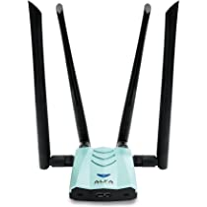 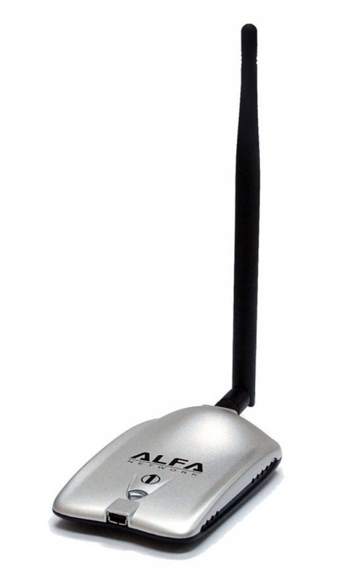

Step by Step tutorial using the **Airgeddon.**

Open terminal on your kali Linux machine and run the command “sudo Airgeddon” to run the Airgeddon.

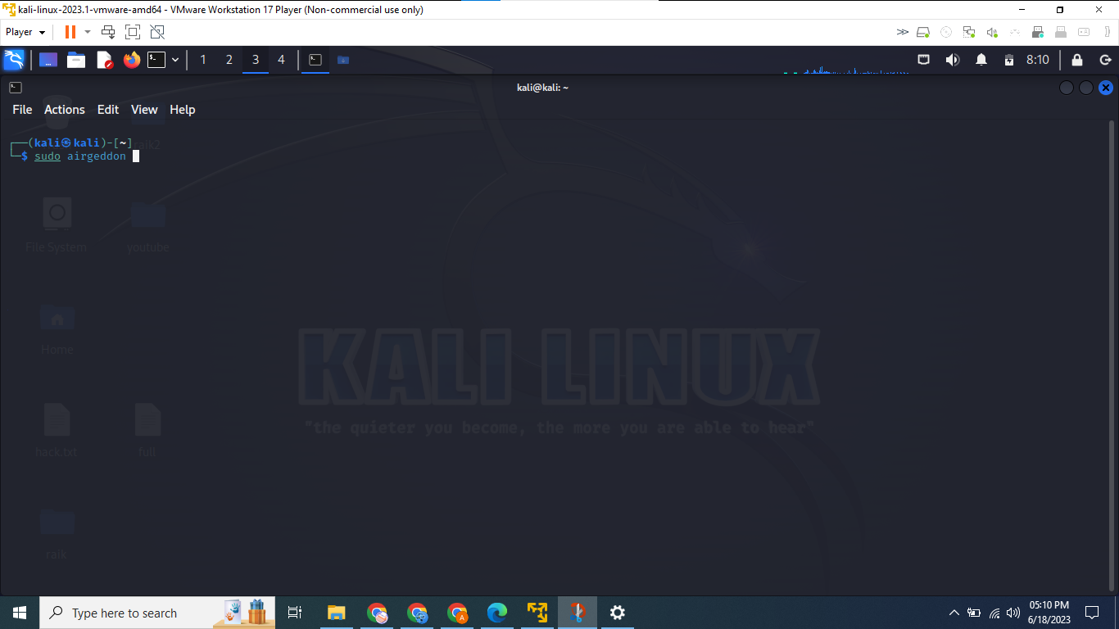

After Sudo Airgeddon

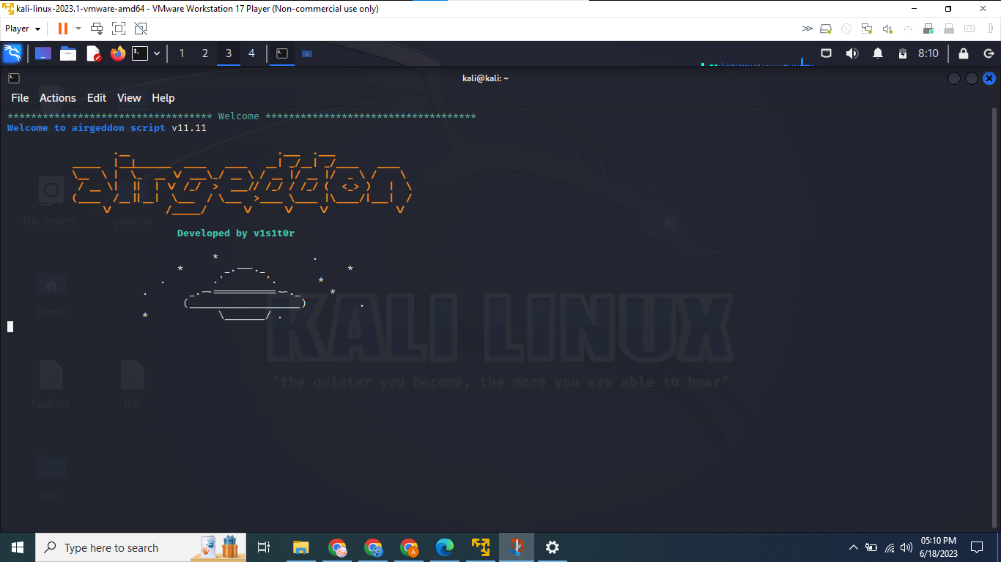

Checking setup

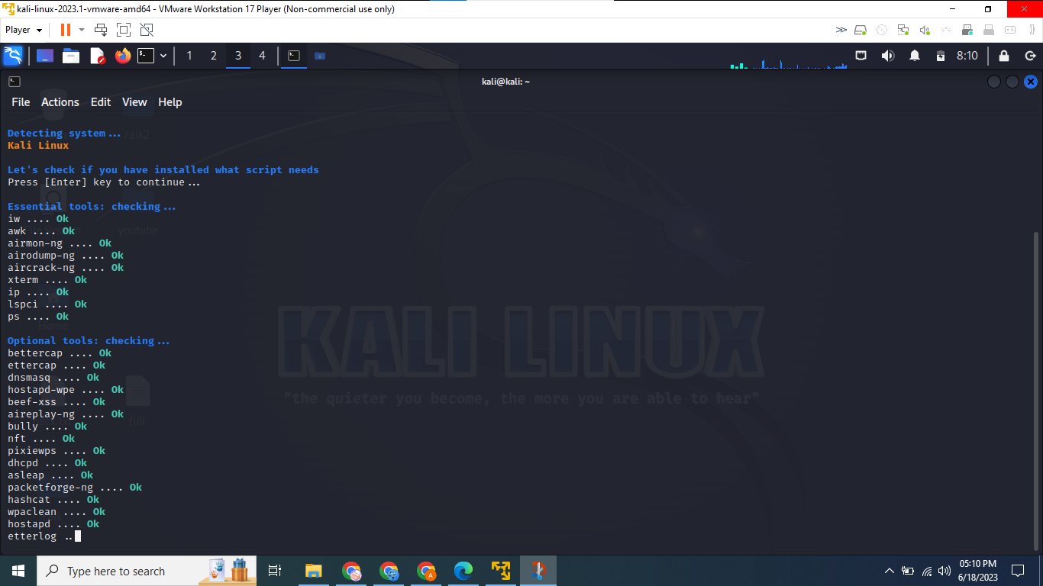

Airgeddon Main Menu

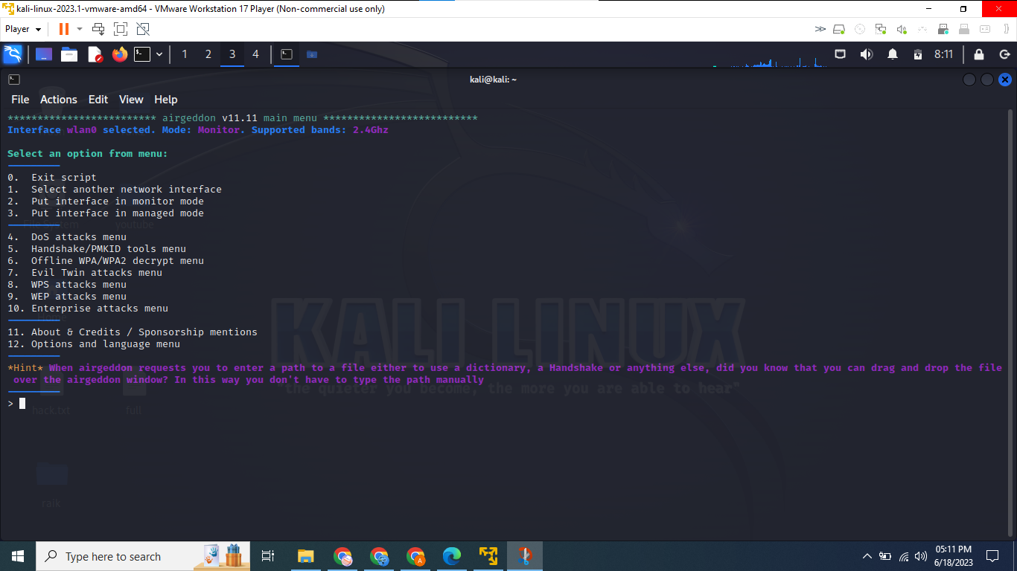

Select to which setting being used

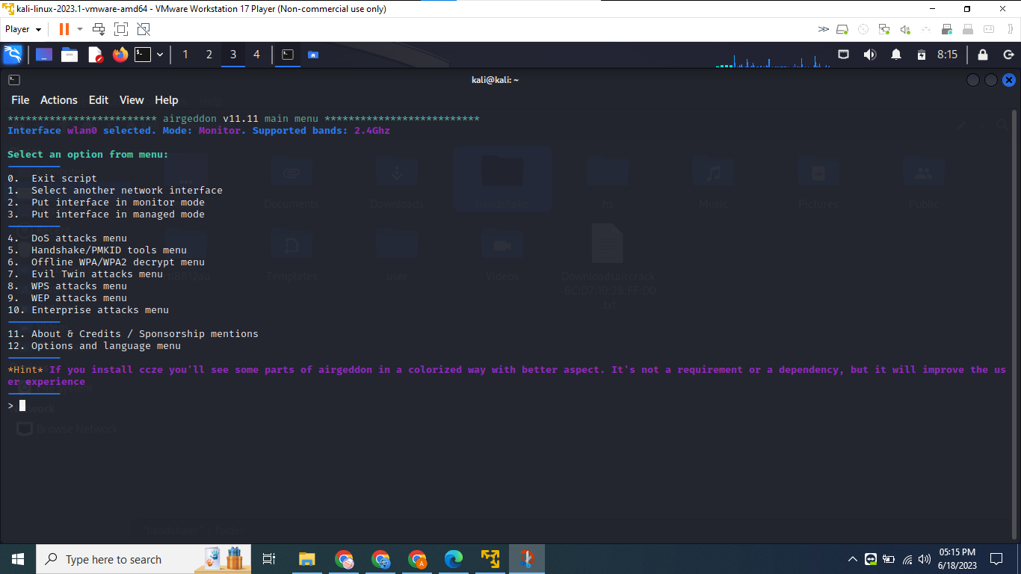

Lists of WiFi Showing

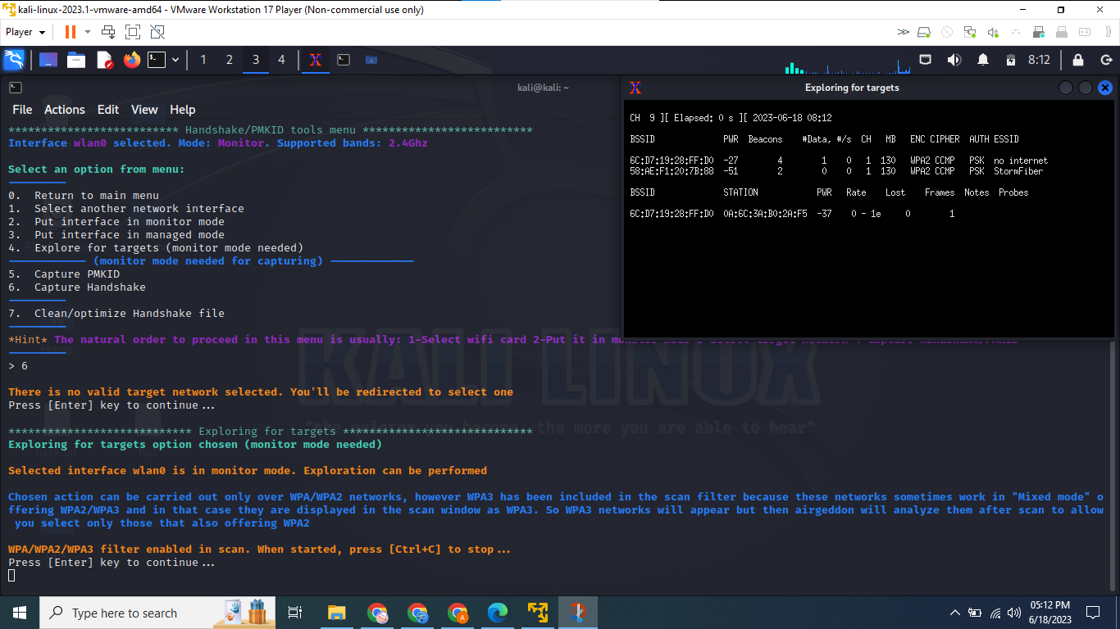

Selecting Target

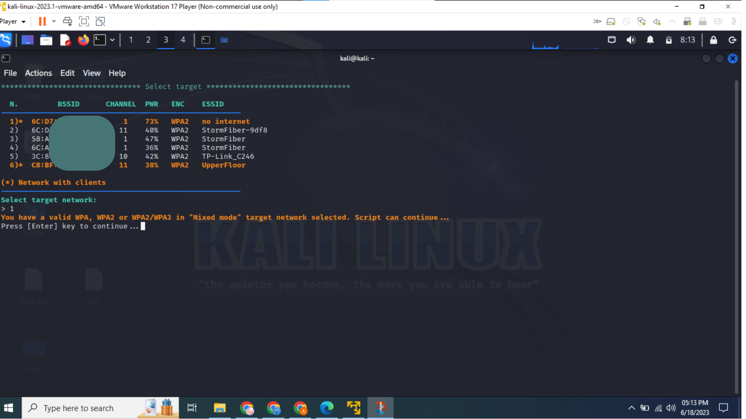

Sending Deauth Packets to target wifi

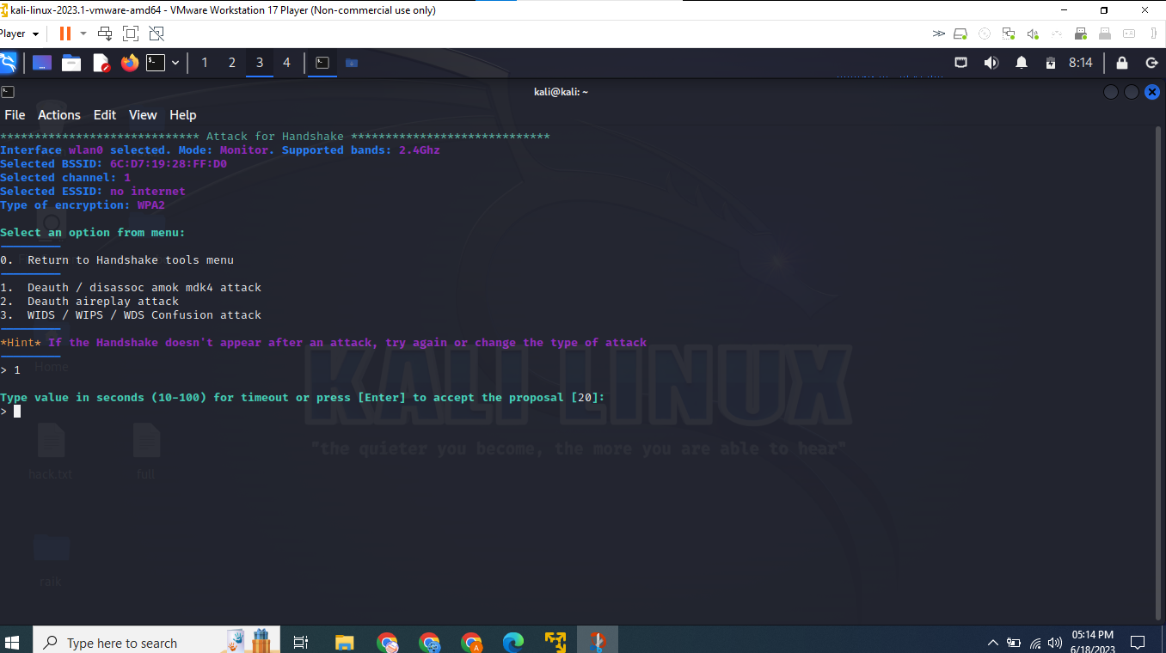

Deauth attack Start

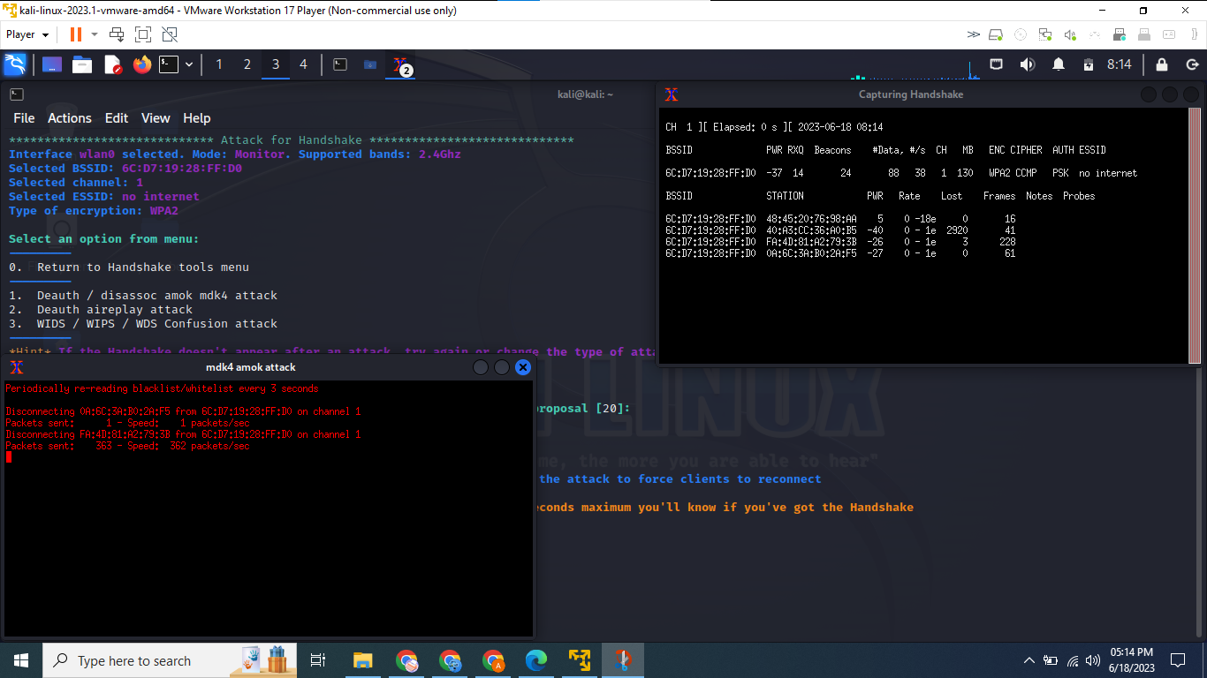

Handshake Captured

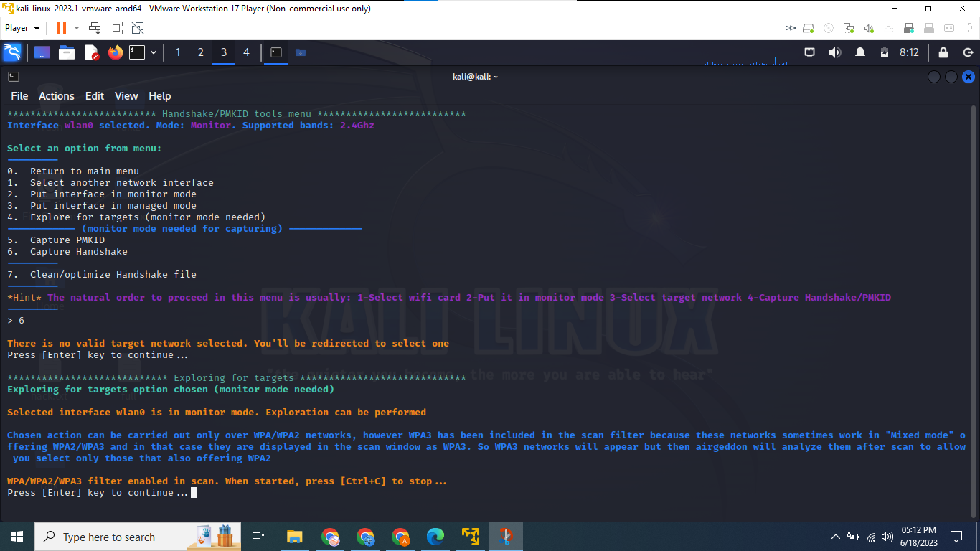

Decrypt Menu

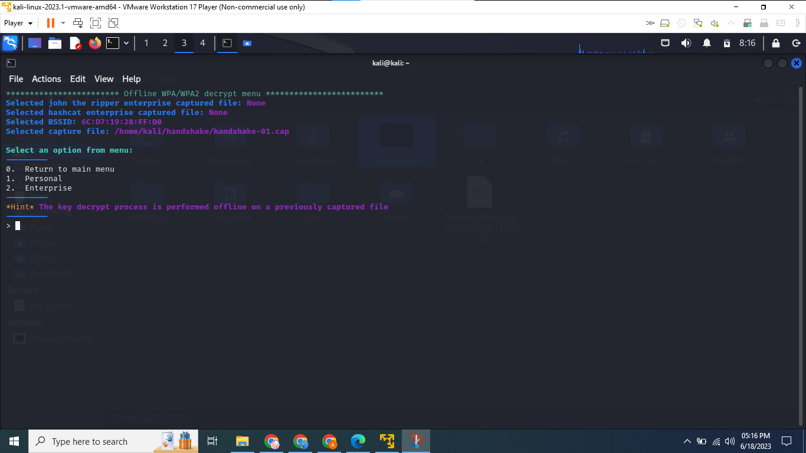

Types of decrypting attack

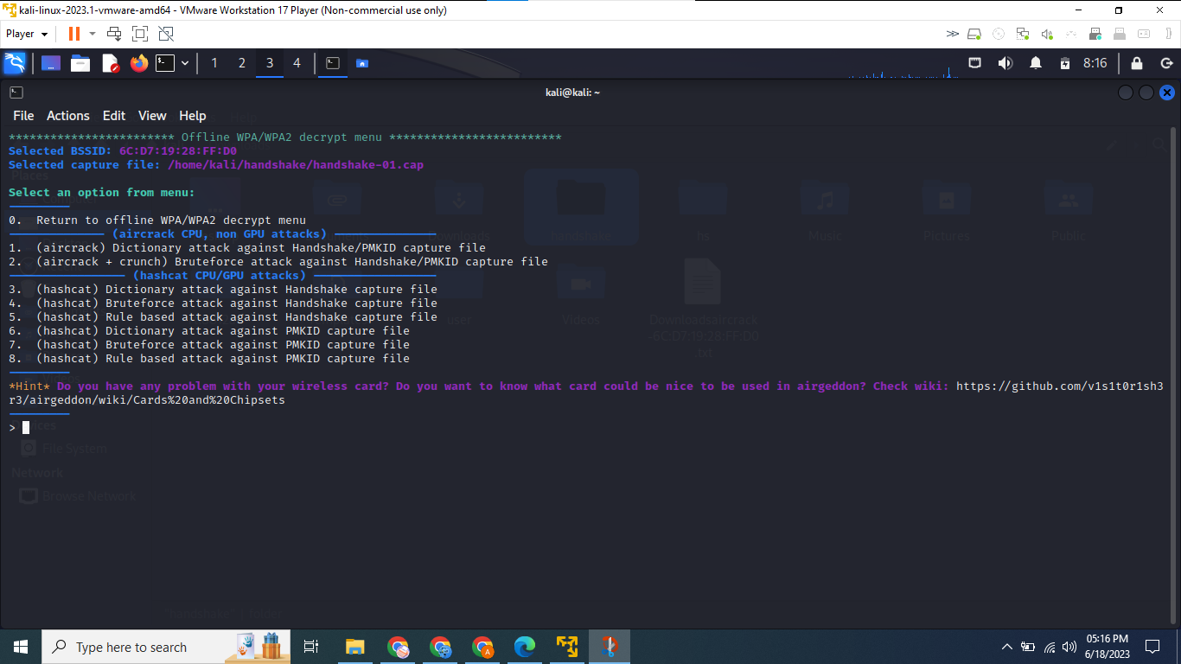

Dictionary File text file

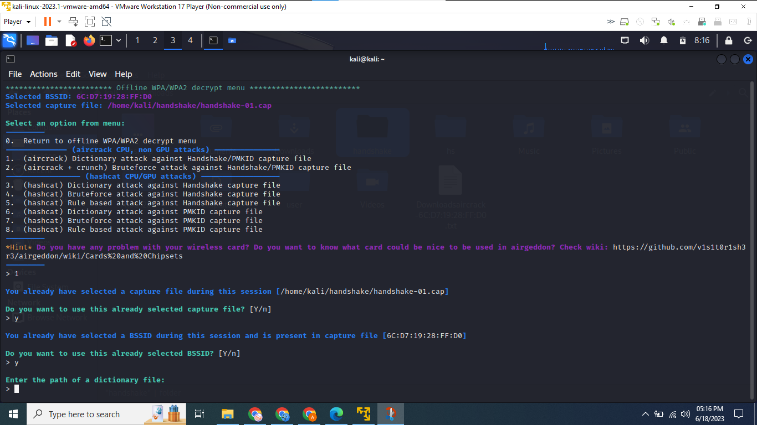

Password Decrypted

